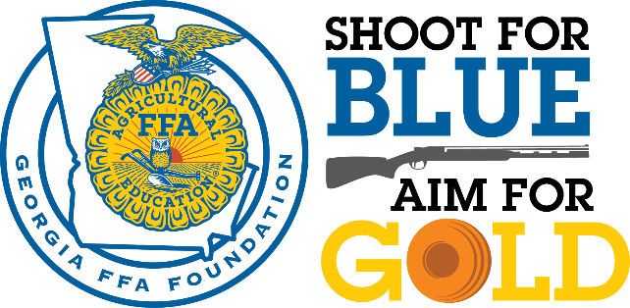
2018 Tournament Sponsor Form
4th Annual Sporting Clays Tournament
June 1st, 2018
Meadows Gun Club
1064 Rumble Road, Forsyth, GA 31029

REGISTRATION DEADLINE: MAY 28th

Sponsor Name:

Contact Name:

Address

City State Zip

Phone Email

Please select one of the following payment options:
Send an invoice to Contact and Address listed above.
Credit Card
Amount to be charged: Name on the Card:
Credit Card Number:
Check enclosed (Please make checks payable to the Georgia FFA Foundation.)

Sponsorship Levels
Title Sponsor(s): $5,000
Sponsorship includes a 4-person shooting team, company logo on all promotional materials and t-shirts, opportunity to have company giveaways in goodie bags. 5 chances per member of the shooting team for the *Sponsors Only* Gun Raffle.

Gold Clay Sponsor(s): $3,000
Sponsorship includes a 4-person shooting team, company logo on all promotional materials and t-shirts, opportunity to have company giveaways in goodie bags. 3 chances per team member for the *Sponsors Only*Gun Raffle.

Silver Shell Sponsor(s): $2,000
Sponsorship includes a 4-person shooting team, company logo on all promotional materials and t-shirts. 2 chances per team member for the Sponsors Only Gun Raffle. 2 chances per team member for the *Sponsors Only* Gun Raffle.

Bronze Barrel Sponsor(s): $1,000
Sponsorship includes a 4-person shooting team, company logo on all promotional materials and t-shirts. Each team member gets one chance for the *Sponsors Only* Gun Raffle.

Station and T-Shirt Sponsor(s): $250 Station Sponsor(s): $100

4-Person Shooting Team: $500 Individual Shooters at $125

*Will your team need a ATV/golf cart?

Team Member Names and T-Shirt Sizes

1. 2.
3. 4.

Please send your company logo and completed form to the Georgia FFA Foundation.
Our address is P.O. Box 237 Swainsboro, GA 30401.
You may also email to Hillery Reeves, hreeves@gaaged.org or fax to 478-289-2584.

For questions or more information, please contact us at 478.289.2555.

